Create Routing in Angular
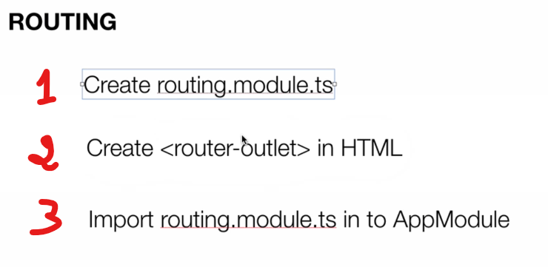

- Create routing with new project
>> ng new project –routing
- Create Manue
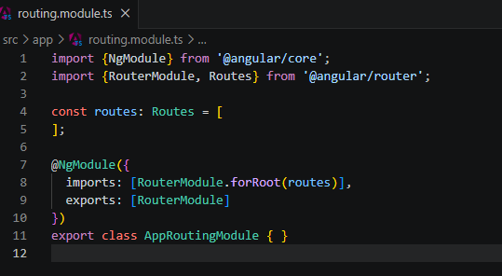

Think of this code as setting up the GPS or navigation system for a website.

- NgModule: This is Angular's way of saying, "Hey, I'm creating a modular brick of code here."
- RouterModule and Routes: These are the specific tools Angular provides to handle website navigation (routing).
- This empty array [] is your map. Right now, it's empty.
- imports: [RouterModule.forRoot(routes)]: This tells Angular, "Take that map we defined above (routes) and initialize the main navigation system for the entire app with it."
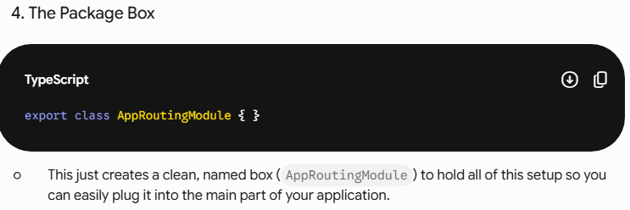

- Create route url and component
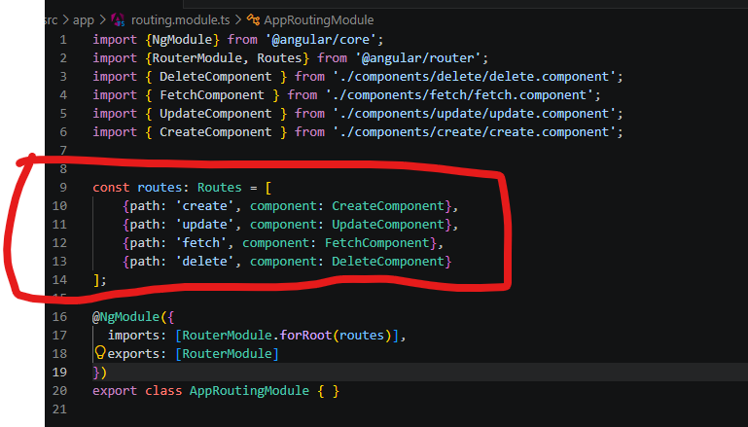

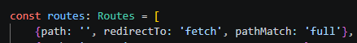

- {path: '', redirectTo: 'fetch', pathMatch: 'full'},​ បើអត់ត្រូវ Path ណាវានឹងទៅ page fetch, ហើយមួយទៀត វាត្រូវការ អោយដូចទៅនឹង path បានដាក់។
Ex: http://localhost:4200/fetch
- Add to app.moudle.ts
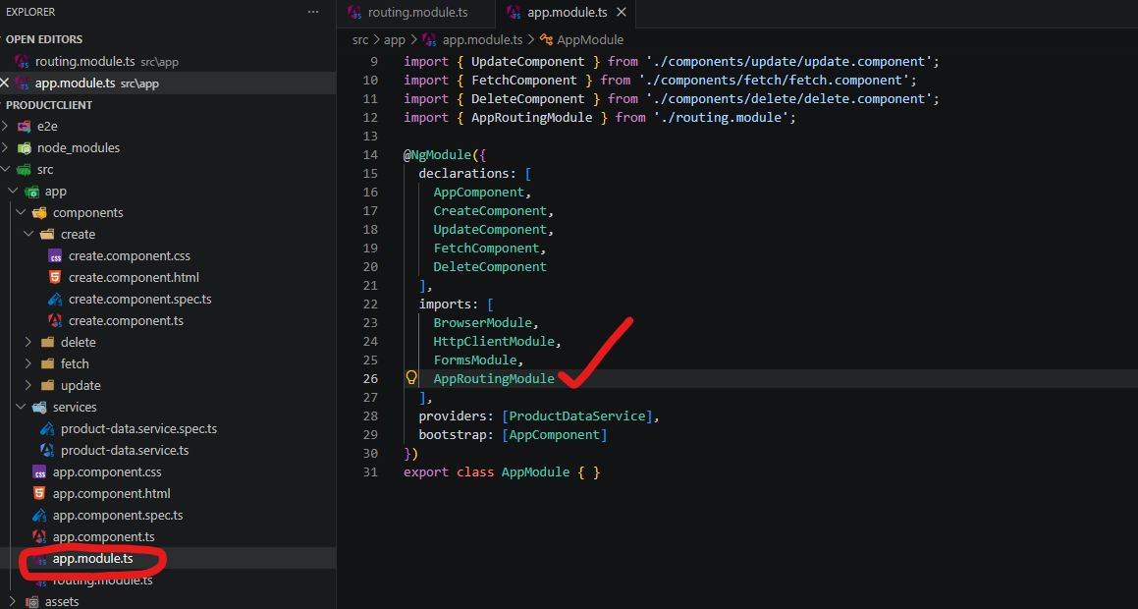

- How to use it in HTML
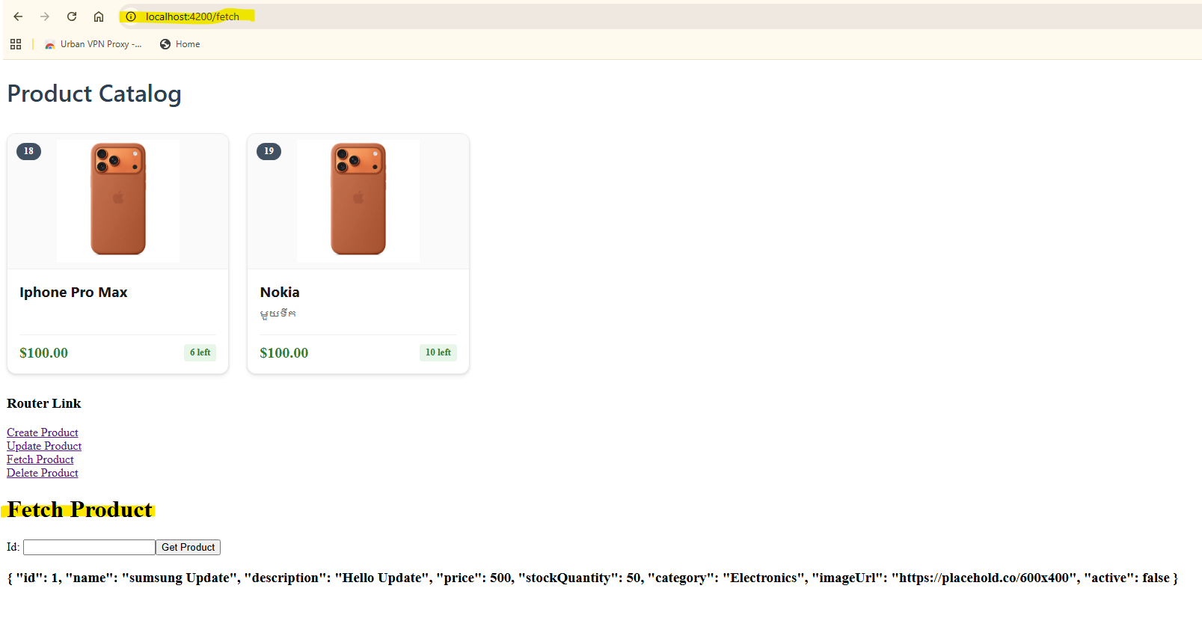

<h3>Router Link</h3>
<a [routerLink]="'/create'"]> Create Product</a><br>
<a [routerLink]="'/update'"]> Update Product</a><br>
<a [routerLink]="'/fetch'"]> Fetch Product</a><br>
<a [routerLink]="'/delete'"]> Delete Product</a><br>

<router-outlet></router-outlet> សម្រាប់ display the route

- [routerLink] : this is the directive from Angular
- <router-outlet></router-outlet> : this the element from Angular

